**Term Paper – MA473**

The value of the option 𝑢(𝑆, 𝑡) is governed by the BS equation:

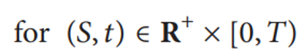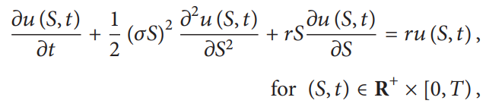

where 𝜎 is a constant volatility of the asset and 𝑟>0 is a constant riskless interest rate.

The final condition is the payoff function Λ(𝑆) at expiry 𝑇:



For certain exotic options it is difficult to find analytic solutions. Thus, we will be using numerical methods to find approximate solutions using different boundary conditions.

Consider a computational domain Ω = [0, 𝐿] as a uniform grid with a spatial step size ℎ = 𝐿/𝑁𝑥 and a temporal step size Δ𝜏 = 𝑇/𝑁𝑡, where 𝑁𝑥 is the number of subintervals and 𝑁𝑡 is the number of time steps.



where 𝑖 = 0, 1, . . ., 𝑁𝑥 and 𝑛 = 0, 1, . . ., 𝑁𝑡.

By applying the fully implicit-in-time and space-centred difference scheme, we have:

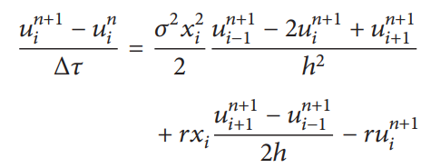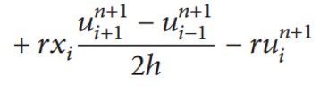

We can rewrite above equation as:



where:

𝛼𝑖 = 𝑟𝑥𝑖/2ℎ − 𝜎2𝑥2𝑖 /2ℎ2,

𝛽𝑖 = 1/Δ𝜏 + 𝜎2𝑥2𝑖 /ℎ2 + 𝑟,

𝛾𝑖 = −𝑟𝑥𝑖/2ℎ − 𝜎2𝑥2𝑖 /2ℎ2,

𝑏𝑖 = /Δ𝜏.

In order to solve the linear system, we need to know $u_{0}^{n}$ and $u_{N_{x}}^{n}$ for all 𝑛 = 0, . . . , 𝑁𝑡. At 𝑥 = 0, we simply set $u_{0}^{n}$ = 0. We will now see five different initial boundary conditions for specifying the values of $u_{N_{x}}^{n}$.

**Dirichlet I Boundary Condition:**

We assume that,

𝑢 (𝐿, 𝜏) = 𝐿 − 𝐾𝑒−𝑟𝜏 for a sufficiently large L.

So, $u_{N_{x}}^{n+1}$ = $x_{N_{x}}$ − 𝐾𝑒−𝑟 (n+1)Δ𝜏

Then, the recursive matrix relation can be seen as follows:

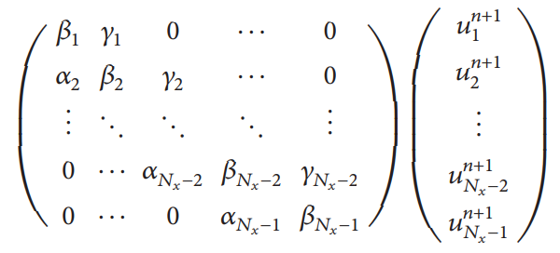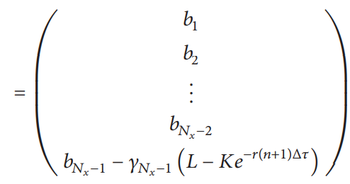

Likewise, we have $u_{N_{x}}^{n+1}$ = C𝑒−𝑟 (n+1)Δ𝜏

**Dirichlet II Boundary Condition:**

For the max call option, we set $u_{N_{x}}^{n+1}$ =𝐿−𝐾:

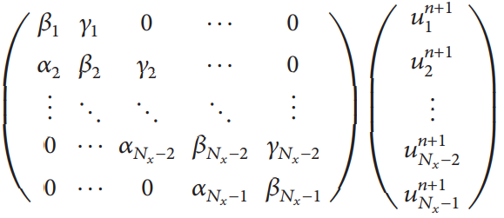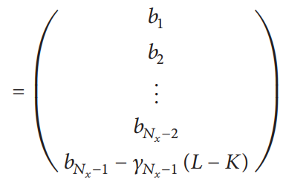

For the cash-or-nothing option, we set $u_{N_{x}}^{n+1}$ = 𝐶.

**Neumann Boundary Condition:**

We know that:

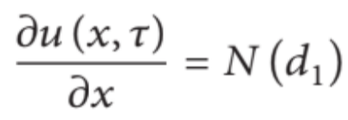

Hence, for a sufficiently large value of L, we can say:

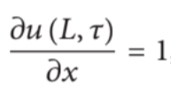

We can discretize the above equation as:

$$u_{N_{x}}^{n+1}= u_{N_{x}-1}^{n+1}+h$$

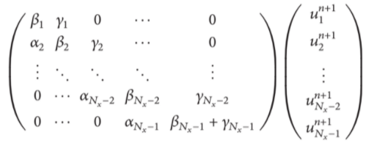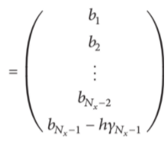

Similarly, for the cash or Nothing option, we have:



Thus, in this case, we get the relation as: $$u_{N_{x}}^{n+1}= u_{N_{x}-1}^{n+1}$$

**Linear Boundary Condition:**

For large values of L, we can argue that for a European Call Option:

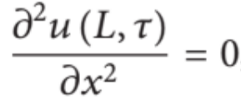

The above equation thus can be discretized as follows:

${(u}_{N_{x}-1}^{n+1}-2u_{N_{x}}^{n+1}+u_{N_{x}+1}^{n+1})/h^{2}$ = 0

By using this relation, we hence obtain the following matrix recurrence relation:

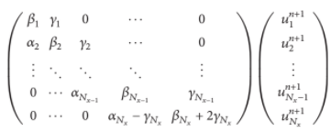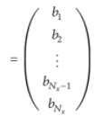

Similarly, for the cash or nothing option, we have obtained the same relation as above.

 (For Cash-or-Nothing Option)

**PDE Boundary Condition:**

We use the BS equation itself to derive the boundary condition.

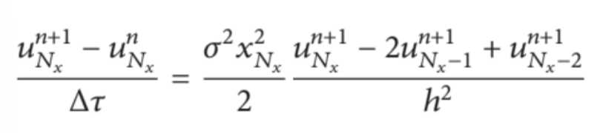 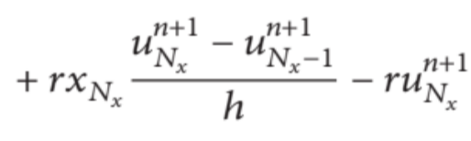

where the drift and volatility terms are discretized by using one-sided derivatives. The linear system of Nx equations can be written in the following matrix form:

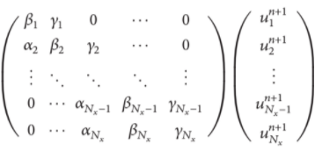 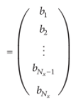



**Dirichlet 1 condition**

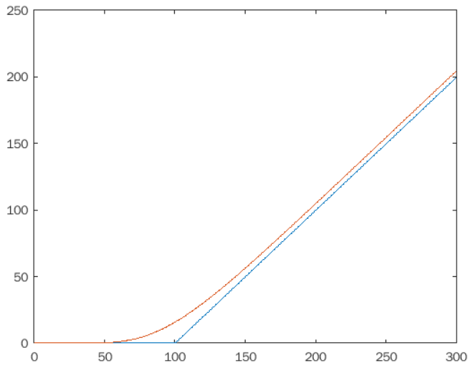 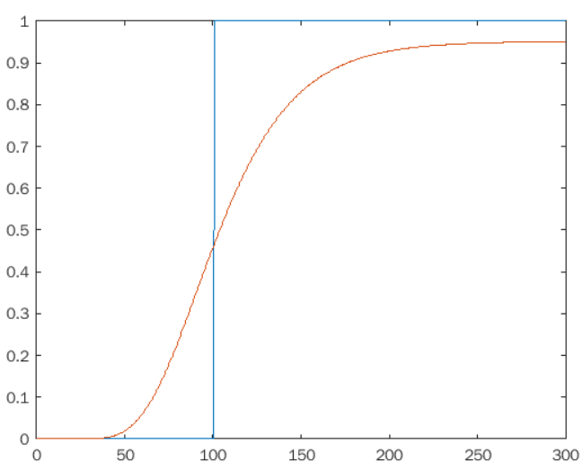

European Call Cash or Nothing

**Dirichlet 2 condition**

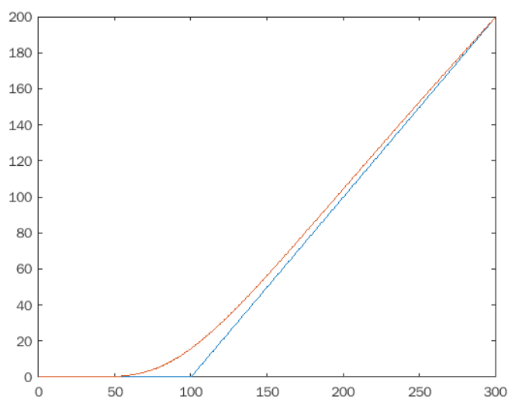 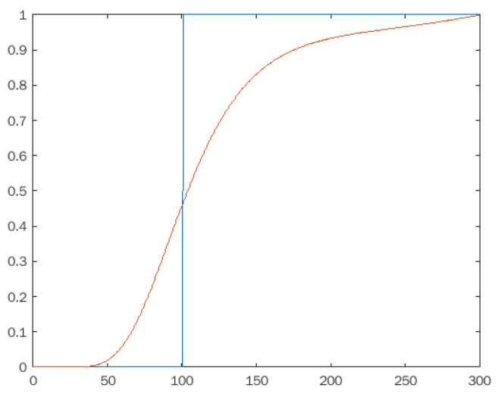

European Call Cash or Nothing

**Neumann Boundary Condition**

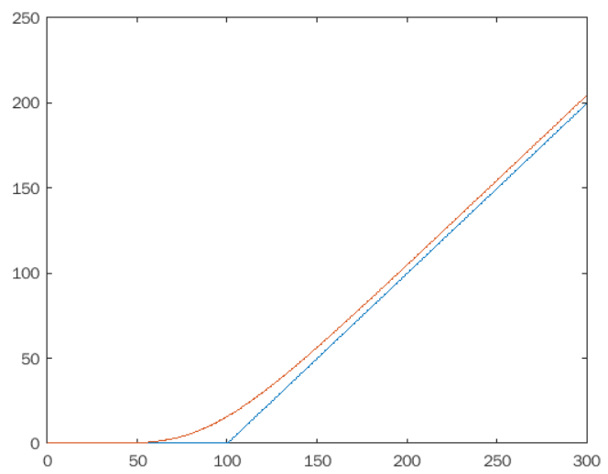 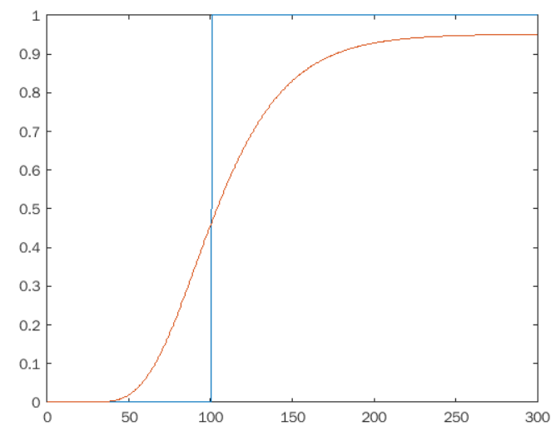

European Call Cash or Nothing

**Linear boundary condition**

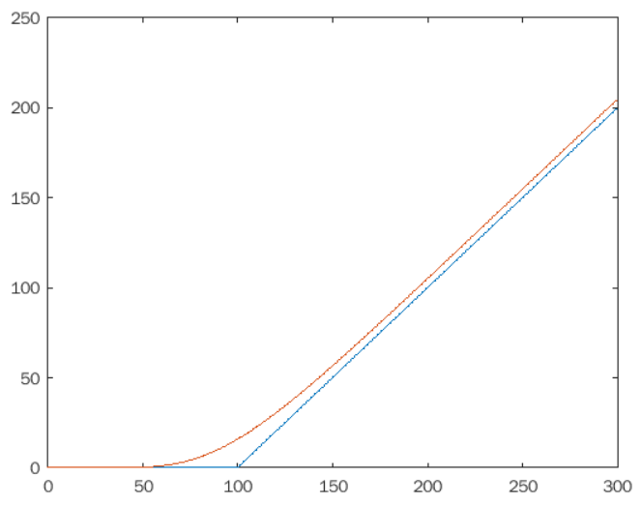 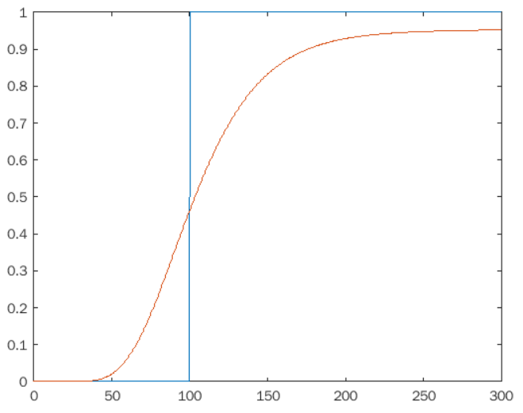

European Call Cash or Nothing

**PDE Boundary Condition**

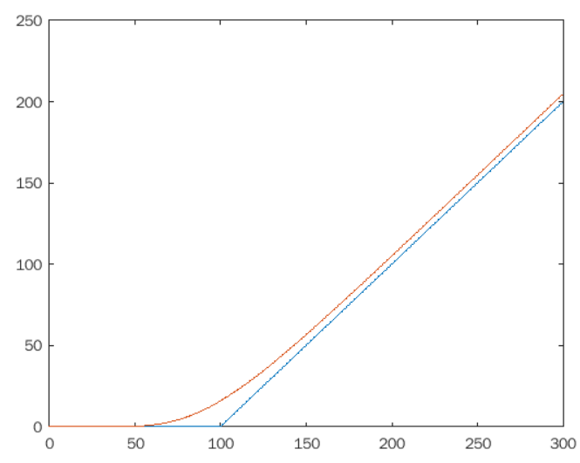 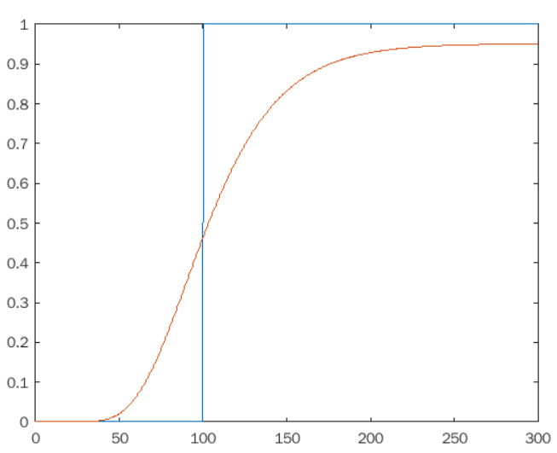

European Call Cash or Nothing

The above graphs were constructed using the following parameters:

L = 300, sigma = 0.35, r = 0.05, K = 100, C = 1

The actual solutions are as follows (using exact solutions of the BS equation):

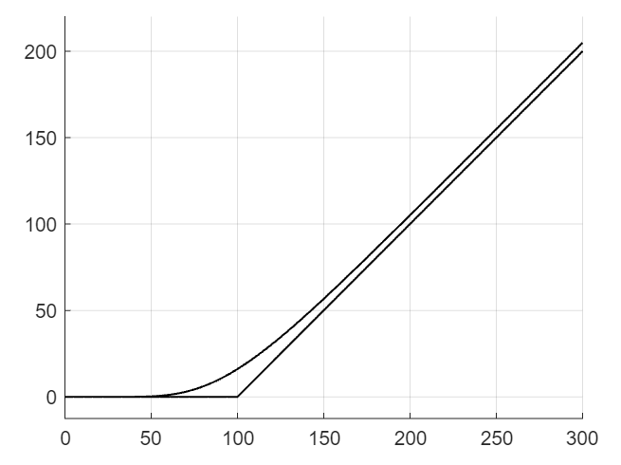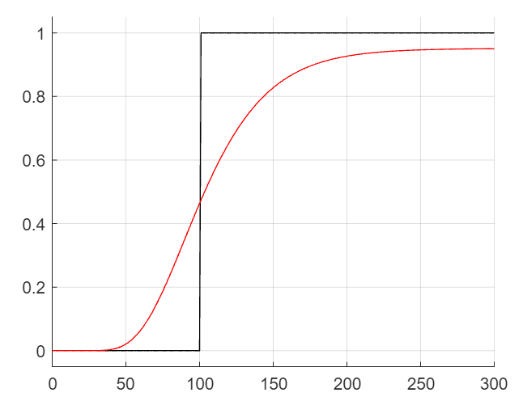

**RMSE Error:**

For each of the 5 methods, we calculate the RMSE errors for all the 5 methods, to test their convergence to the actual solutions.

